# **COMPONENT DIAGRAMS**

1. **LIBRARY MANAGEMENT SYSTEM**

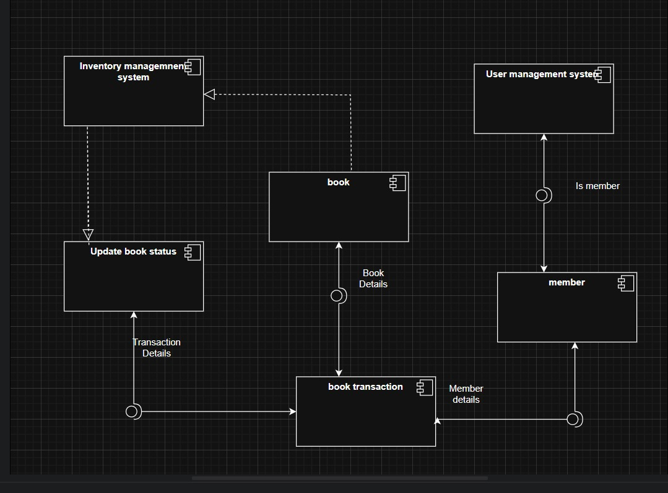

**2) ONLINE SHOPPING**

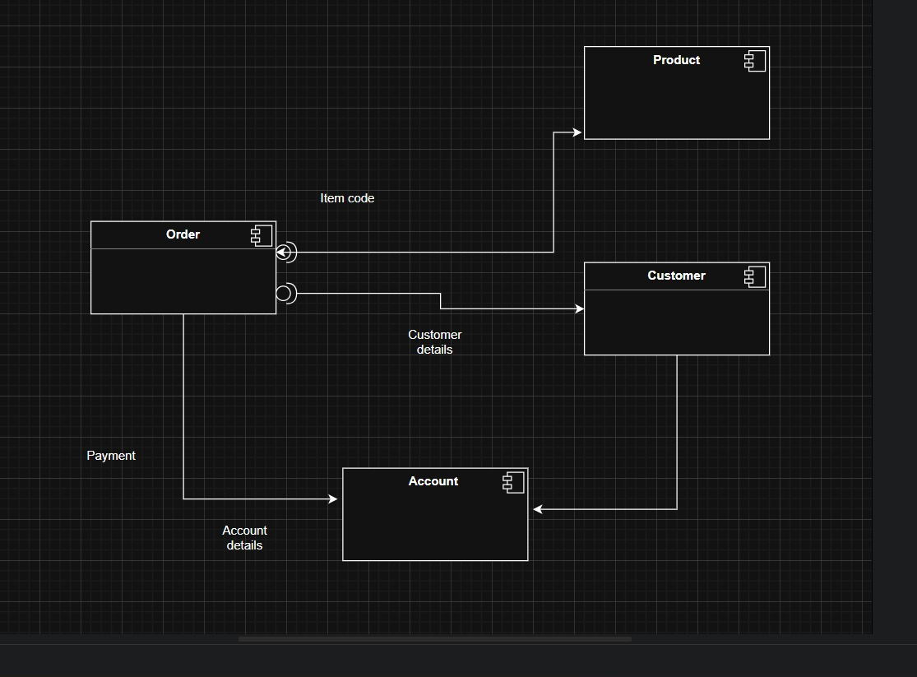

## 

## 

## 

## 

## **2)Deployement Diagram**

1. **Online Shopping**

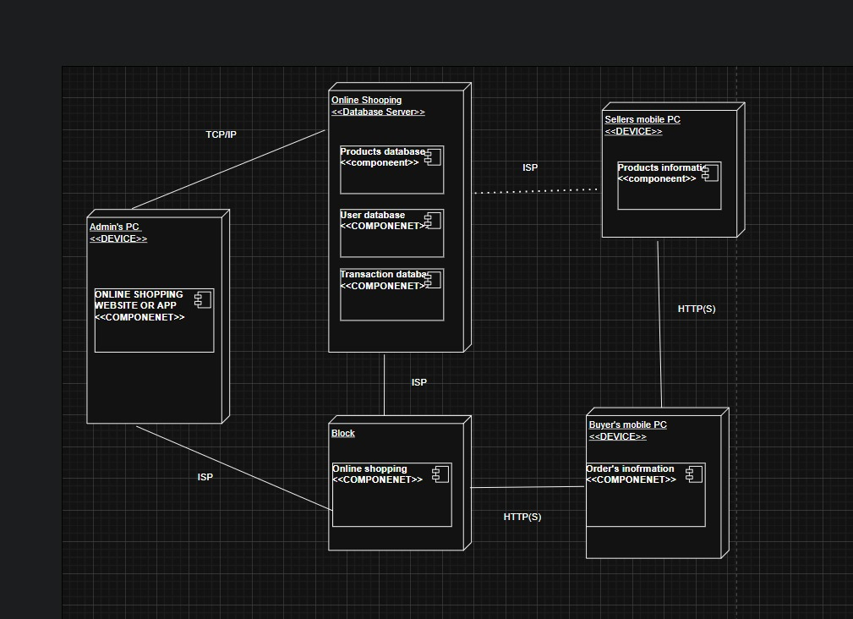

**2)Library Management**

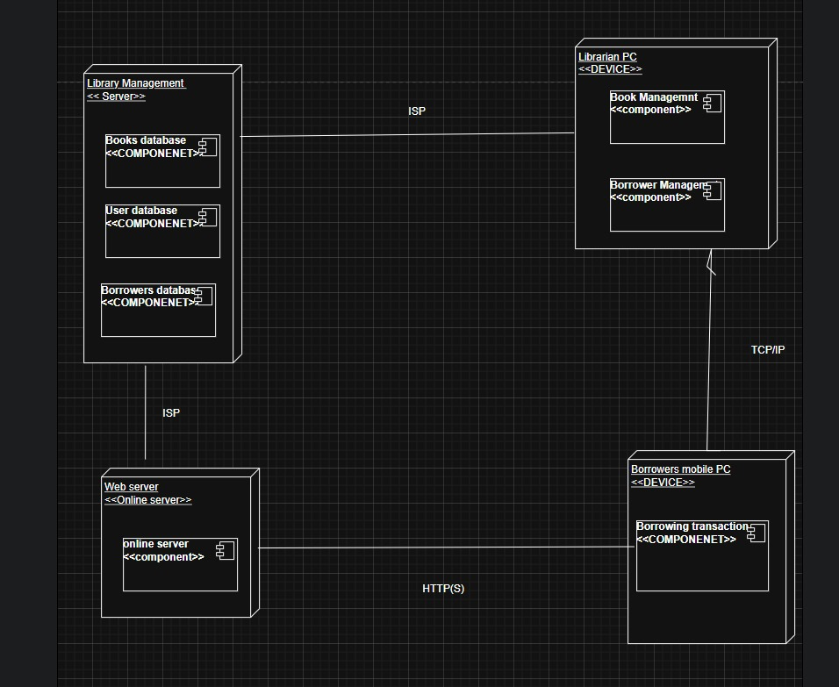

## 

## 

## 

## 

## 

## **3)Collaboration Diagram**

**1)Library Management System**

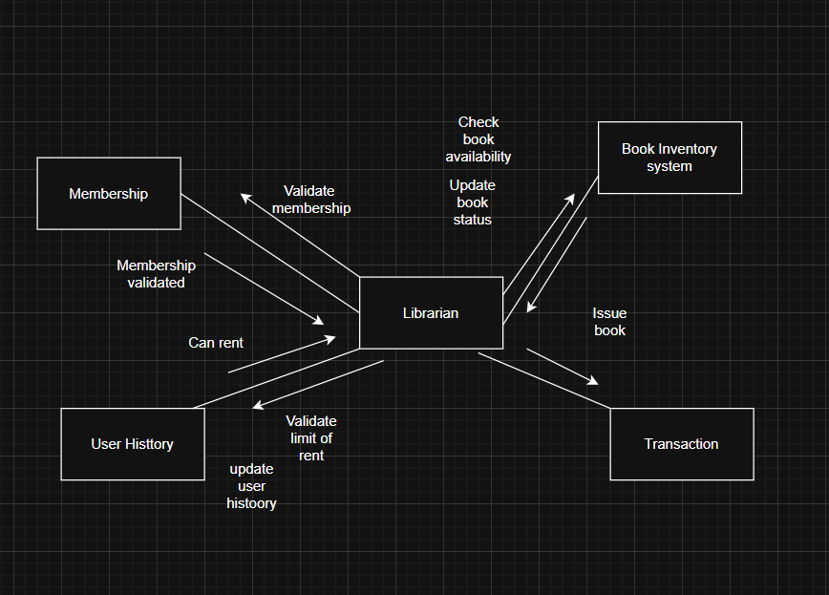

**2)Online Shopping**

